Lab. Practice #2

Berk ARSLAN

# Image Thresholding

First of all, the maximum and the minimum values of the image are determined. Then alfa value is given and the equation is applied and each pixel is compared with threshold level which is set and if it is lower than the level it is adjust as the threshold level.

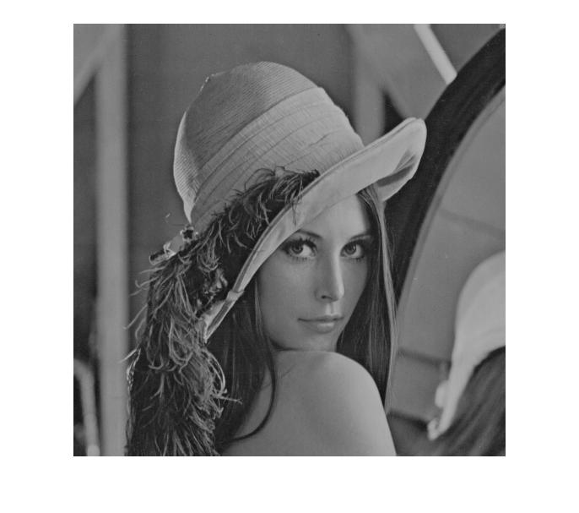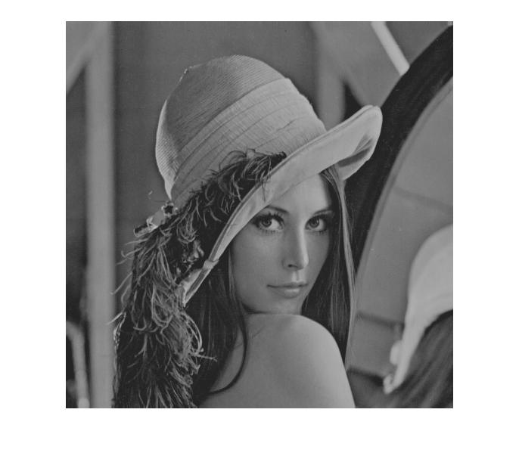 Lena alfa = 10%

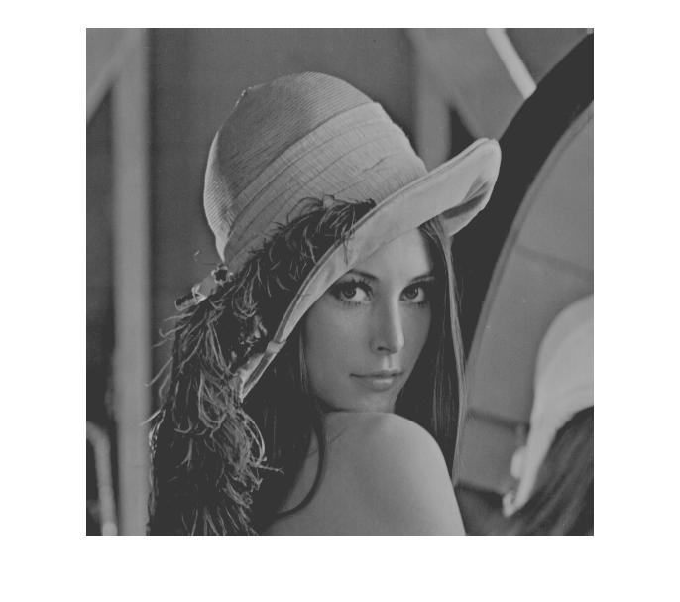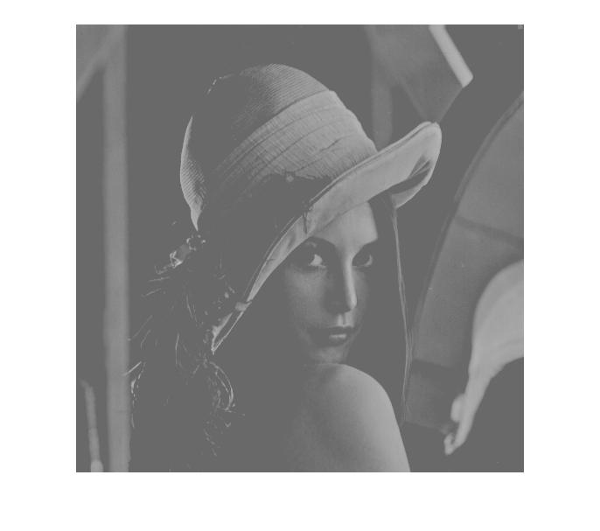 alfa = 20% alfa = 50%

# Histogram Equalization

In the algorithm of equalization, the main purpose is to contrast the image which has histogram as concentrated at middle values.

Firstly, a code is defined to calculate histogram values with a loop which accesses each pixel value and counts them. Then matlab's “cumsum” function is used to determine to the cumulative histogram instead of code and loop crowd.

Secondly, cumulative distribution function is defined and new histograms are defined.

Finally, the equalized image is generated according to cumulative distribution function.

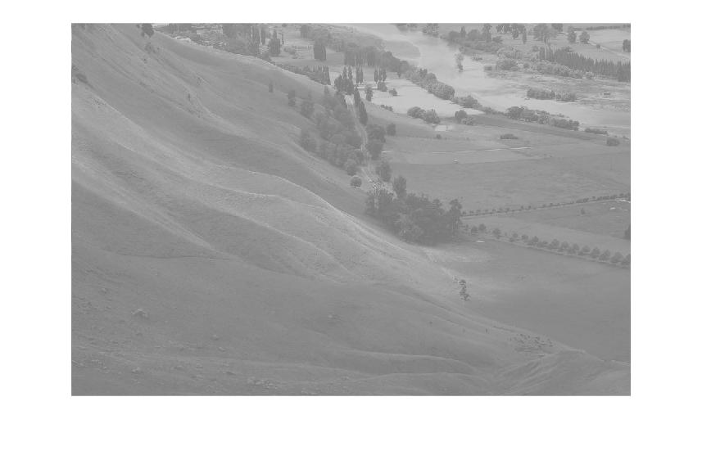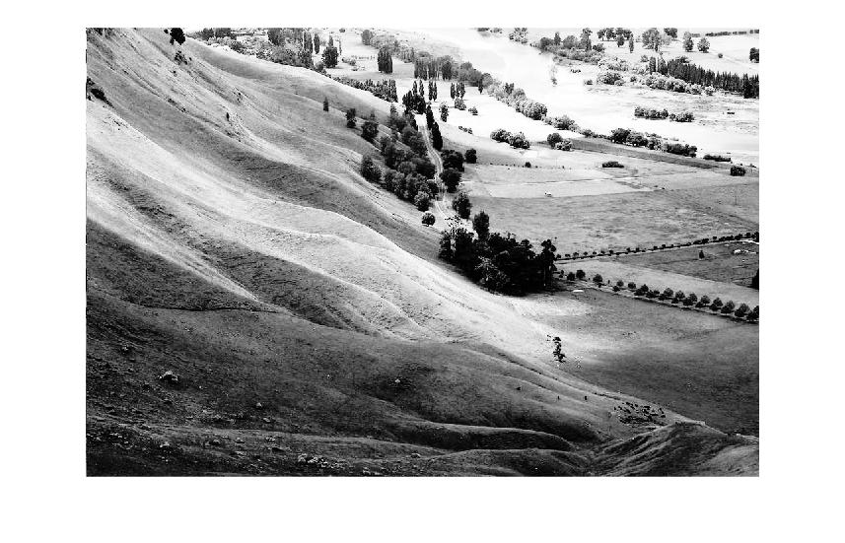 Original Equalized

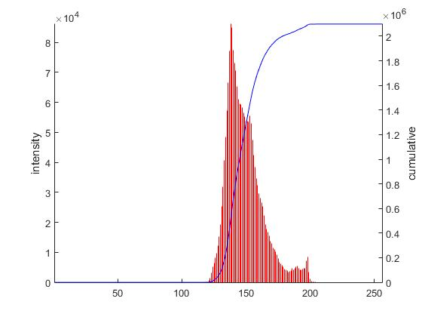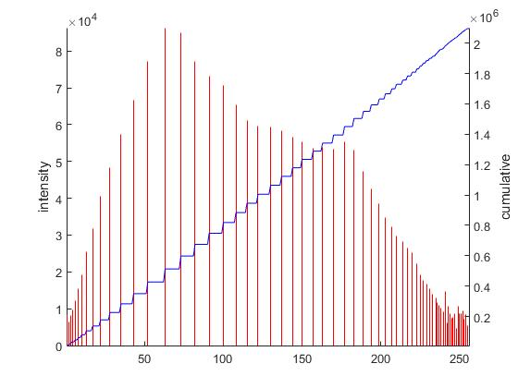 Original Histogram Equalized Histogram

### Comparing with Matlab's Algorithm

Algorithm which belongs to Matlab has different output. Main difference is that it is darker comparing with the previous equalized image however contrast is not very different.

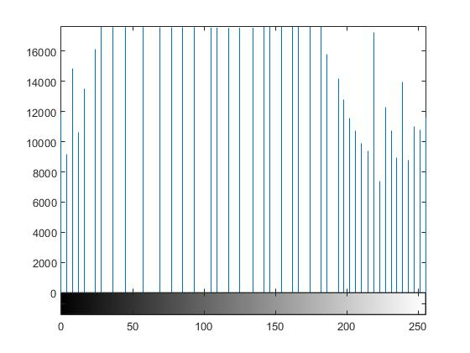 *Matlab's Outputs*

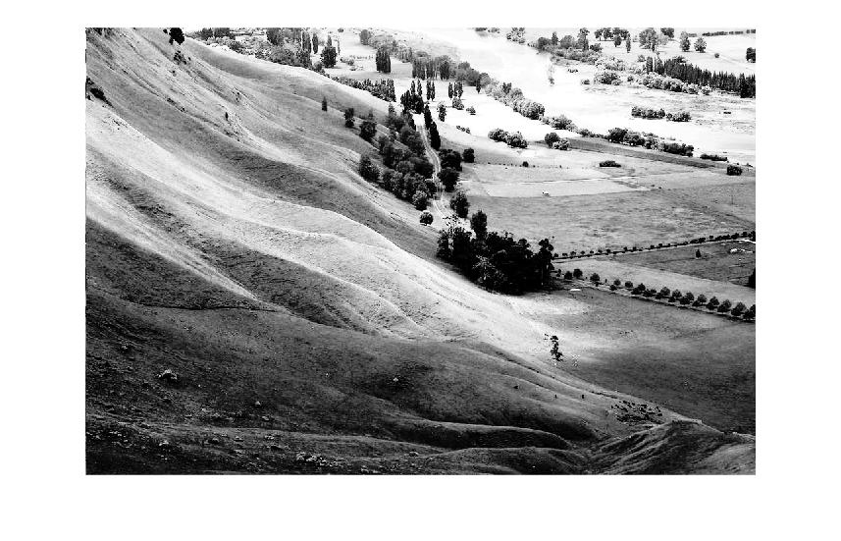

### Different Input Image

Another input image is tried with the algorithm and compared with Matlab's algorithm.

However both of them are failed because the original image has big contrast and the middle range of gray levels are so low, so the algorithms are tried to distribute the huge black tones to middle zone.

There is no big differance between Matlab's algorithm's output and the my algorithm's output.

Original

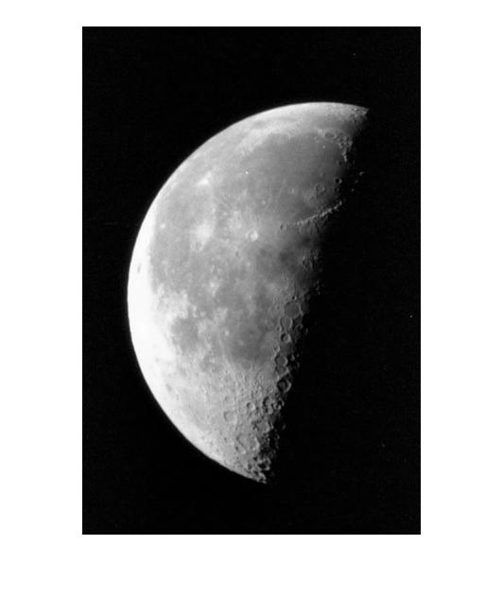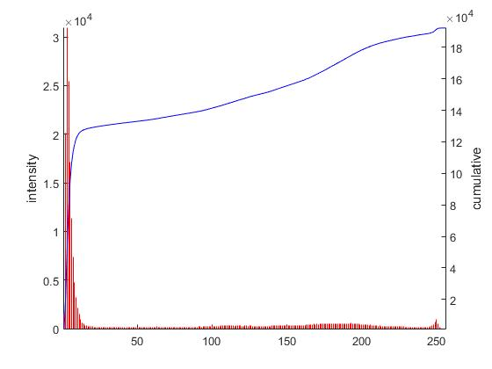

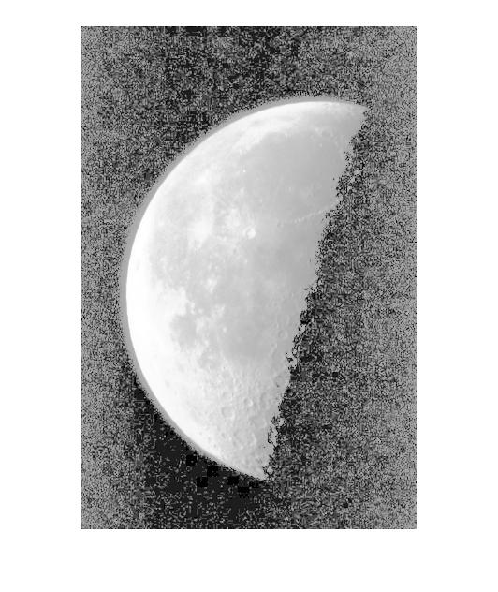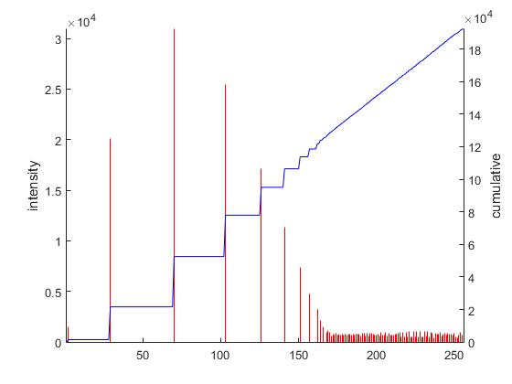Developed Algorithm

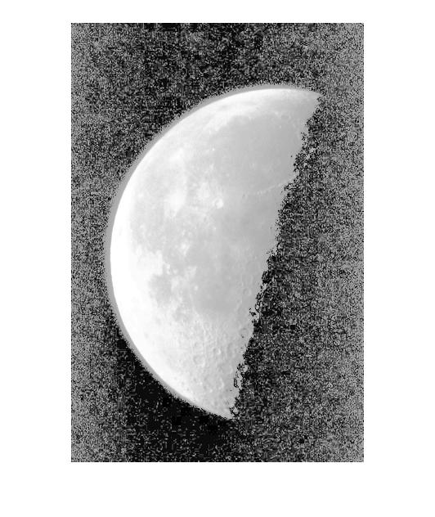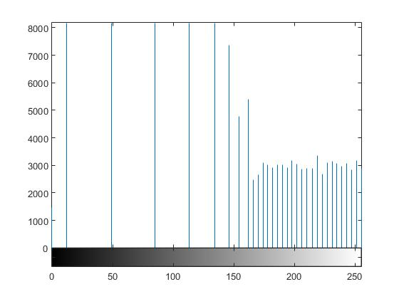

Matlab's Algorithm